Definition of data warehouse :-

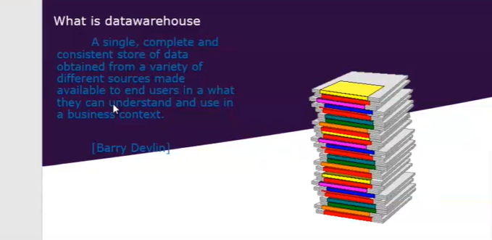

Difference between Online Transaction Process vs DWH

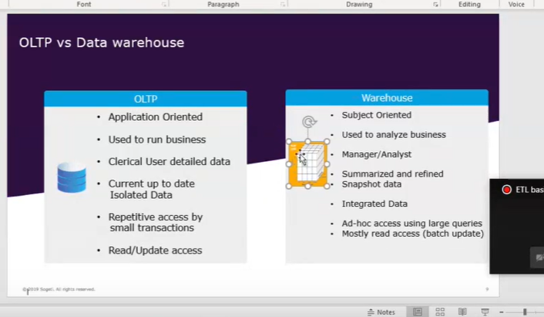

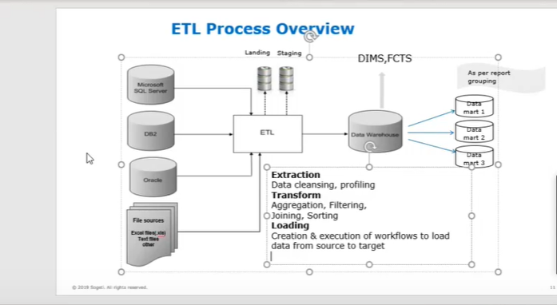

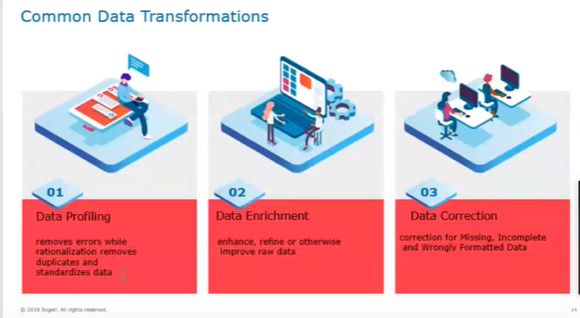

Definition of Fact table vs Dimension table :-

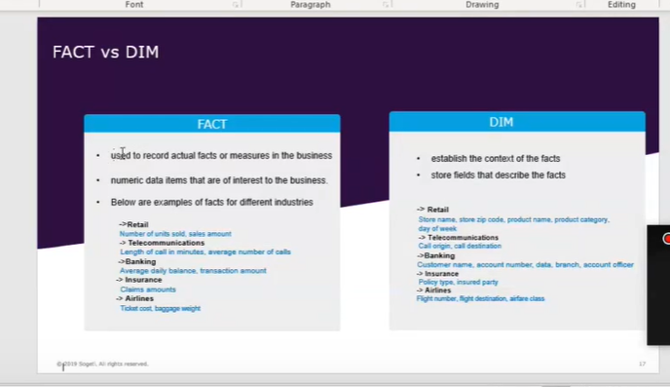

9) What are the differences between data warehousing and data mining?
OLTP | OLAP
OLTP stands for Online Transactional Processing. | OLAP stands for Online Analytical Processing.
OLTP is a relational database, and it is used to manage the day to day transaction. | OLAP is a multidimensional system, and it is also called a data warehouse.

10) What is a dimension table and how it is different from the fact table?
Suppose a company sells its products to its customer. Every sale is a fact which occurs within the company, and the fact table is used to record these facts. Each fact table stores the primary key that joins fact table with the dimension table and measures/ facts.

A dimension table which store attributes or dimensions describe the objects in a fact table. It is a set of companion tables to a fact table.

11) What is a Data Mart?
Data Mart is a simple form of Data Warehouse, and it is focused on a single functional area. It gets the only from few sources.
For example: In an organization, data marts may exist for marketing, finance, human resource, and other individual departments which stores the data related to their specific functions.

Key Differences Between Star, Snowflake, and Galaxy Schema
 | Star Schema | Snowflake Schema | Galaxy Schema
Elements | Single Fact Table connected to multiple dimension tables with no sub-dimension tables | Single Fact Table connects to multiple dimension tables that connects to multiple sub-dimension tables | Multiple Fact Tables connects to multiple dimension tables that connects to multiple sub-dimension tables
Normalization | Denormalized | Normalized | Normalized
Number of Dimensions | Multiple dimension tables map to a single Fact Table | Multiple dimension tables map to multiple dimension tables | Multiple dimension tables map to multiple Fact Tables
Data Redundancy | High | Low | Low
Performance | Fewer foreign keys resulting in increased performance | Decreased performance compared to Star Schema from higher number of foreign keys | Decreased performance compared to Star and Snowflake. Used for complex data aggregation.
Complexity | Simple, designed to be easy to understand | More complicated compared to Star Schema – can be more challenging to understand | Most complicated to understand. Reserved for highly complex data structures
Storage Usage | Higher disk space due to data redundancy | Lower disk space due to limited data redundancy | Low disk space usage compared to the level of sophistication due to the limited data redundancy
Design Limitations | One Fact Table only, no sub-dimensions | One Fact Table only, multiple sub-dimensions are permitted | Multiple Fact Tables permitted, only first level dimensions are permitted

